**Use Checkbox For Selecting Multiple Rows From af:table**

One of the feature which existed in JDeveloper 10g but not found in JDeveloper 11g is using checkbox for selecting multiple rows from af:table.  
This is my workaround for achieving this feature in JDeveloper 11g. Follow this steps:  
  
1- Make a new ADF fusion web Application.  
2- choose your database connection. (assume we are using HR Schema)  
3- Make one viewObject based on entity (assume Employees viewObject based on Employees Entity)  
[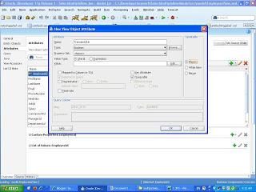](http://4.bp.blogspot.com/_gtyEuru9PjQ/SyanF_V0gOI/AAAAAAAAACQ/BGqyhTB7lEI/s1600-h/1.JPG)4- Open your Employees ViewObject and make a new transient attribute with type boolean and make it always updatable (assume the transient Attribute name is 'TransientAttr').

[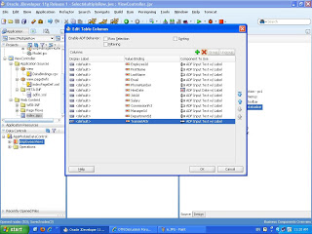](http://4.bp.blogspot.com/_gtyEuru9PjQ/SyanY0X8mEI/AAAAAAAAACY/aZF5uOHPnw0/s1600-h/2.JPG)5- Make a new page and drag your employee view as a table and don't check on Row Selection checkbox.  
[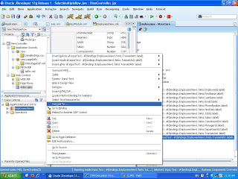](http://3.bp.blogspot.com/_gtyEuru9PjQ/SyanpD_CwfI/AAAAAAAAACg/meZMsSee5d4/s1600-h/3.JPG)6- In your Structure Palette goto your inputText Transient attribute and right click and choose Convert to.

7- From opening dialog choose Select Boolean Checkbox ---> Ok ----> Ok.

[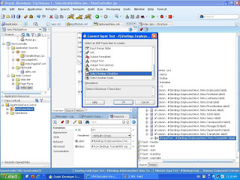](http://2.bp.blogspot.com/_gtyEuru9PjQ/Syan66kmowI/AAAAAAAAACo/ZKsmwjLREMI/s1600-h/4.JPG)  
8- Make the selectBooleanCheckbox component AutoSubmit with true and put its Id in the table partialTrigger and clear its lable and text.

[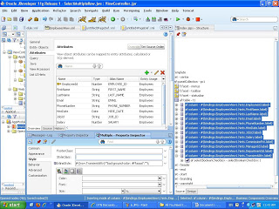](http://1.bp.blogspot.com/_gtyEuru9PjQ/SyaoPneiWXI/AAAAAAAAACw/Zr74Qv1feCY/s1600-h/6.JPG)

9-

Select all columns and goto Style Property and inlineStyle write

this #{(row.TransientAttr)?"background-color: #ffaaaa":""};  
where #ffaaaaa is the color of the selected row (you can change this color as you want).  
[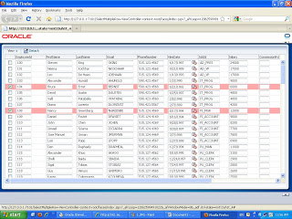](http://4.bp.blogspot.com/_gtyEuru9PjQ/SyaosX4af1I/AAAAAAAAAC4/Z8lIvVPp5Vs/s1600-h/8.JPG)10-Now any row has its transient Attribute with true value, this row will be selected row.